Holocene thinning and grounding-line retreat of the Darwin-Hatherton glacier system, Antarctica

Abstract

Outlet glaciers of the East Antarctic Ice Sheet thickened throughout the Transantarctic Mountains during Marine Isotope Stage 2 (29 – 14 kyr BP) and fed a grounded ice sheet in the Ross Embayment. Exposure and radiocarbon ages of glacial deposits in four ice-free areas alongside Hatherton and Darwin glaciers record several hundred meters of late Pleistocene to early Holocene thickening relative to present, followed by thinning through the Holocene, as the grounding-line of the Ross Sea Ice Sheet retreated to the south. The significant finding is that Darwin and Hatherton glaciers retreated from their high-stands later than glaciers farther south, only reaching their modern configuration ≤2.8 kyr BP. We propose that the convergence of Darwin Glacier with other large outlet glaciers may have slowed grounding-line retreat, while retreat continued unopposed in the central Ross Embayment.

*[You may be planning for this, but include some statement about modeling results]*

**Introduction**

*The last deglaciation in the Ross Embayment*

A thick ice sheet filled the Ross Embayment of Antarctica during Marine Isotope Stage 2 (MIS-2; XX-XX kyr BP), grounded near Coulman Island (73° S) (Anderson et al., 2014). Between 13 and 2 kyr BP, the grounding-line retreated >1,200 km to its current position along the Siple Coast. Conway et al. (1999) proposed that grounding-line recession followed the pattern of a swinging gate, with its hinge in the eastern Ross Sea. They based this hypothesis on three lines of evidence: (i) Radiocarbon ages of mollusk colonies, shells, and seals on beaches in Northern Victoria Land require the presence of open water by 8 cal. kyr BP. (ii) Radiocarbon ages of freeze-dried algae found in former ice-marginal ponds alongside Hatherton Glacier, a tributary of Darwin Glacier, suggest that the glacier system reached its present configuration before 6.8 kyr BP (Bockheim et al., 1989). (iii) An ice flow model of Roosevelt Island best fits the observed Raymond bump (Raymond, 1983) in radar layers if divide flow initiated ~3.2 kyr BP.

This chronology has been repeatedly modified with multiple new lines of evidence. Martín et al. (2006) used a thermomechanically-coupled transient model to refine the estimate of the initiation of divide flow at Roosevelt Island. They found that a high power (n=4) rheology is required to match the shape of the Raymond bump, and that divide flow likely initiated 3.0 +1.2/-0.7 kyr BP. Todd et al. (2010) mapped and dated deposits alongside Reedy Glacier, and showed that thinning initiated ~13 kyr BP and had largely ceased by 1 kyr BP. Exposure ages from deposits alongside Shackleton and Beardmore Glaciers show that these glaciers had reached modern elevations by 7.4 kyr BP, and the chronology at Scott Glacier shows that the Ross Ice Shelf grounding-line reached its present position between Reedy and Scott Glaciers around 3 kyr BP (Spector et al., 2017). This suggests that the 1100 km-long section of the TAMs front deglaciated almost contemporaneously in the early Holocene, followed by slow recession into the late Holocene.

Anderson et al. (2004) used a numerical model of the Darwin-Hatherton glacier system to show that fluctuations of Hatherton Glacier may have lagged changes at the mouth of Darwin Glacier by as much as 1100 years. This uncertainty causes considerable overlap with ages from Bockheim et al. (1989) with the date of deglaciation in Northern Victoria Land at 7.8 kyr BP. However, Anderson et al. (2004) did not have knowledge of the bed topography or basal conditions at Hatherton or Darwin Glaciers; analysis like this should therefore be revised using new data from aerial and ground geophysics surveys (Gillespie et al., 2017) in order to evaluate the best model of glacier flow.

In this paper, we revisit the chronology of the Darwin and Hatherton glaciers since the penultimate glaciation with new surface exposure ages of glacial erratics and of bedrock, as well as radiocarbon ages of freeze-dried algae. Advances in radiocarbon dating since the 1980s and the advent of surface-exposure dating allow us to examine the history of this glacier system with higher spatial resolution and temporal data constraints than available for previous interpretations (Bockheim et al., 1989). The data presented here are not sufficient to define the response time of Hatherton Glacier to changes at the mouth of Darwin Glacier. So, we use a 1.5-dimensional finite-volume flowband model to determine what can be deduced about Last Glacial Maximum (LGM) and deglaciation conditions at the mouth of Darwin Glacier from the more complete chronologies we have constructed from alongside Hatherton Glacier.

*Physiographic setting of Darwin and Hatherton Glaciers*

Darwin Glacier and its major tributary Hatherton Glacier are outlet glaciers of the East Antarctic Ice Sheet that flow through the TAM into the modern Ross Ice Shelf. In contrast to the neighboring fast-flowing Byrd and Mulock glaciers, ice-flow velocities for the Darwin-Hatherton glacier system do not exceed 110 m yr-1, and everywhere the velocity of Hatherton Glacier is <12 m yr-1 (Rignot et al., 2011; Gillespie et al., 2017). The glaciers have a very small catchment within the East Antarctic Ice Sheet, due to both high bedrock topography preventing flow into their canyons and to the proximity of the much larger Byrd and Mulock glaciers, whose catchments effectively behead the Darwin-Hatherton catchment (Swithinbank, 1988; Gillespie et al., 2017). While Byrd and Mulock glaciers contribute about 22 and 5 Gt a-1 to the Ross Ice Shelf, respectively (Stearns, 2011), Darwin Glacier only contributes 0.24 ± 0.05 Gt a­-1 (Gillespie et al., 2017).

The surface mass balance of the Darwin and Hatherton glaciers is spatially complex, with persistent blue ice patches and seasonal surface melt (Brown & Scambos, 2004; Gillespie et al., 2017). The boundary layer meteorology is dominated by strong, dry, and cold downslope winds between April and September, with mean monthly air temperatures around -25°C (Noonan et al., 2015). In December and January, humid winds dominate, and mean monthly temperatures rise to -4°C. Blue ice areas form due to convergence of katabatic winds and to turbulence as the winds flow over mountains and nunataks (Bintanja, 1999). Therefore, most ablation on the Darwin-Hatherton system likely occurs during the winter months, due to removal of surface snow by strong downslope winds. Brown and Scambos (2004) showed that blue ice areas on Darwin Glacier are likely very near their maximum extent, and only small climate fluctuations are required to greatly reduce their area. Gillespie et al (2017) noted that of the avilable gridded data products that provide estimates of the surface mass balance over the Darwin-Hatherton glacier system—i.e., van de Berg et al. (2006); Arthern et al. (2006); Lenaerts et al. (2012b) (27 km); and Lenaerts et al. (2012a) (5.5 km), only the 5.5 km simulation of Lenaerts et al. (2012a) includes ablation areas; however, the spatial pattern of ablation does not match observed blue ice extents.

The Darwin-Hatherton glacier system includes multiple lakes and ponds, ranging from large frozen lakes at the glacier margins (e.g., Lake Wellman, Lake Judith, Lake Hendy, and Lake Wilson in Location Figure), seasonal supraglacial ponds at low elevations, and isolated moraine-dammed ponds around Diamond Hill (Webster-Brown et al., 2010). While Lake Wellman and Lake Hendy are likely frozen through to their beds, Lake Wilson is capped by floating ice, with a stratified water column ~100 m deep (Webster, 1996; Hendy, 2000). All of these environments host modern blue-green algae (cyanobacterial mats), which are the living equivalents of the material dated by Bockheim et al. (1989), King et al. (in press), and this paper.

Gillespie et al. (2017) provided the first measurements of ice thickness and characterized the bed using ground-based and airborne ice-penetrating radar. The modern grounding-line of Darwin Glacier sits on a forward sloping bed ~925 m below sea level. The bed reflection there is weak, with abundant hyperbolae that likely represent basal crevasses. Downstream of the grounding-line the basal reflection grows stronger and smoother, as basal melting removes the basal crevasses and creates terraces on the ice shelf base. Hydrostatic equilibrium is not achieved until ~2.5 km downstream of the grounding-line.

Further into the Ross Ice Shelf, ice from the Darwin-Hatherton system is compressed between the converging Byrd and Mulock glaciers (Map Figure). On the south side of the Byrd Glacier flowband, tensile crevasses and rifts are oriented ~45° to flow; however, the pressure exerted by Darwin and Mulock on the north side of Byrd Glacier causes the crevasses and rifts on the north side to be angled ~30° to flow (Hughes et al., 2017). Thomas et al. (1984) measured positive vertical strain rates along this flowband south of Minna Bluff. They suggested that the convergence of the Byrd Mulock, Darwin, and Skelton glaciers, along with routing of flow past Minna Bluff cause intense creep thickening of the ice shelf in the region. Hughes et al. (2017) posited that Byrd Glacier effectively buttresses ice from West Antarctica by acting as a “nail” in the Ross Ice Shelf. Therefore, the history of ice dynamics in this region may be key to understanding grounding-line retreat of the West Antarctic Ice Sheet during the last deglaciation.

*The Darwin-Hatherton Glacier System during MIS-2 and the Holocene*

Outlet glaciers throughout the TAM thickened first at their mouths during MIS-2 in response to thickened, grounded ice in the Ross Sea, and later at their heads due to increased accumulation after the LGM (Todd et al., 2010). Lateral moraines of MIS-2 age have been used to interpret ice thicknesses of both the grounded Ross Ice Sheet and EAIS outlet glaciers (Bockheim et al., 1989; Denton et al., 1989; Todd et al., 2010; Spector et al., 2017).

Bockheim et al. (1989) mapped lateral moraines and drift sheets in ice-free valleys alongside Hatherton Glacier, and dated these deposits based on weathering, soil characteristics, and a small number of radiocarbon ages of freeze-dried algae. These algae grew in glacier-dammed ponds, and they died as the glacier thinned and drained the ponds after the local LGM. These ages thus provide a good proxy for the glacier margin position through time, subject to the uncertainties of the pond size (any ref here?). Bockheim et al. (1989) tentatively attributed the Britannia II drift sheet to the LGM, and interpreted the Britannia I drift several hundred meters inboard as a Holocene readvance or stillstand. They named the unweathered drift sheet immediately adjacent to the glacier margin the Hatherton drift. Two much older drifts they termed the Danum (MIS-6) and Isca (much older, but undated).

The Britannia II drift lies 100 m above the current glacier margin at the head of Hatherton Glacier, and 450 m above the current margin in the middle of the glacier profile. Bockheim et al. (1989) extrapolated this to infer up to 1100 m of thickening at the confluence of Darwin Glacier with the Ross Ice Sheet during MIS-2, although they found no deposits there. Anderson et al.’s (2004) numerical model yielded a more modest 800 m of thickening. Forthcoming cosmogenic *in situ* 14C measurements from bedrock at the mouth of Darwin Glacier will constrain the LGM ice thickness at the mouth of Darwin Glacier.

Storey et al. (2010) revisited the Lake Wellman area, where Bockheim et al. (1989) found 450 m of LGM thickening, and used surface exposure dating to determine the age of the Britannia and Hatherton drift limits. Their ages for the Britannia drift range from 22 to 182 kyr BP, but they interpreted a cluster of five ages with a mean of 35 kyr BP to represent the age of the drift sheet. They correlated the Hatherton drift, only 70-100 m above glacier level, to minor LGM thickening or a Holocene deglaciation event. These interpretations would indicate either that Hatherton Glacier did not respond to thickening of ice in the Ross Sea during MIS-2, or that ice in the Ross Sea did not ground and thicken during MIS-2. These results are in conflict with the vast majority of glacial geological data (e.g., Baroni and Hall, 2004; Conway et al., 1999; Denton et al., 1989; Stone et al., 2003; Todd et al., 2010; Bromley et al., 2010), marine geologic data (e.g., Shipp et al., 1999; Domack et al., 1999), geophysical data (e.g., Price et al., 2007; Conway et al., 1999), and model results (e.g., Anderson et al., 2004; Waddington et al., 2005; Martín et al., 2006; Pollard and Deconto, 2009; Whitehouse et al., 2011).

Joy et al. (2014) revisited the upper Hatherton Glacier in order to date the deposits in Dubris and Bibra Valleys using surface exposure dating. They showed the Britannia II drift is in fact of MIS-6 age, and the Britannia I drift is of Holocene in age. Using Storey et al.’s (2010) conclusion that lower Hatherton Glacier did not thicken at the LGM, they suggested that the ice thickness of the upper Hatherton Glacier is predominantly controlled by accumulation-driven fluctuations of the EAIS, and that the EAIS ice was thinner during the LGM. However, the LGM in Antarctica is known to be later than the global LGM by thousands of years (Stone et al., 2003; Hall et al., 2015), and the Holocene age of the Britannia I drift is in agreement with ages from glaciers throughout the TAM (Todd et al., 2010; Spector et al., 2017).

The deglaciation chronology of the Darwin-Hatherton glacier system has been used as one of three key constraints in the swinging gate model of Ross Sea grounding-line retreat (Conway et al., 1999), but this chronology was based on a handful of bulk radiocarbon ages, which likely resulted in an averaging effect on the ages. Furthermore, these samples were collected alongside Hatherton Glacier, which is >50 km from the modern grounding-line, and is influenced both by a lagged response to grounding-line position and by changes in surface mass balance. It is therefore necessary to gain a more regional view of the deglaciation history of these glaciers in order to accurately assess the timing both of the establishment of the modern grounding-line position and of steady flow at Hatherton Glacier.

*Description of Deposits*

We refer the reader to the comprehensive paper by Bockheim et al. (1989) for a more complete description of the deposits. Here we only summarize the general characteristics of each deposit, noting observations pertinent to our chronology that may be missing from the description of Bockheim et al.

**…**

**Methods**

*Exposure dating of glacial erratics and bedrock*

*Radiocarbon dating of sub-fossil algae*

*Numerical model*

*[Do you want me to help with writing some of this section? Or at least I can hack in heavily after you get something down, though you may have text around from class projects that will be plenty of description—also feel free to use anything from the proposal, do you have a copy of that?]*

**Results: Exposure dating**

Hatherton Glacier

*Britannia II*

Our chronology supports the conclusion of Joy et al. (2014) that the Britannia II deposit is a product of the penultimate glaciation. While Joy et al. give a mean 10Be age of 126 ± 3.2 kyr BP (n = 5), we find an 26Al age of 141 ± 3 kyr (n = 9; reduced Χ2 = 1.35). Recalculation of Joy et al.’s ages using an updated estimate of the 10Be production rate yields an age of 138 ± 4 kyr, in close agreement with our 26Al age. Our initial attempt to date the Britannia II limit using 10Be resulted in a widely spread dataset (FIGURE), which yielded an age of ~133 kyr BP (n = 9; reduced Χ2 = 57.9). This underestimation of 10Be ages is consistent throughout most of the samples that we dated using both 10Be and 26Al. We attribute it to a persistent analytical bias at the CAMS accelerator during analysis.

*Britannia I*

The Britannia I drift limits alongside Hatherton Glacier reveal a stable maximum extent between 7.5 and 8.5 kyr BP (Figure 4). Variations in the age of the limit of deposition are to be expected, as many variables can control the local scale dynamics of the glacier margin, including local wind patterns, air temperatures, and bed topography (need citation here; this is really just a thought). Therefore, the 7.5 kyr BP age of the limit on Updog Mountain should not be interpreted as differing significantly from the 8 kyr or 8.2 kyr ages from the nearby Danum Platform and Dubris Valley. The probability peak at Magnis Valley is slightly older than the upper valleys, at ~8.6 kyr BP; however, as these ages are reported with 1-sigma errors, this is likely not statistically significant.

*Lake Wellman*

While we were not able to obtain reliable exposure ages from the Britannia deposits in the Lake Wellman area, radiocarbon ages of algae from lakes and ponds show a strong dependence of age on elevation, with a stable maximum position from 13 kyr BP until ~8 kyr BP, followed by steady thinning to modern elevations by the late Holocene. Bockheim et al. (1989) and Storey et al. (2010) were not able to differentiate between the Britannia I and II drifts at Lake Wellman, but King et al. (2017) mapped the Britannia II limit slightly outboard of the Britannia I limit. There were no algae present in the Britannia II drift, and we did not sample it for surface exposure dating.

Darwin Glacier

We visited the Brown Hills and Diamond Hill, adjacent to Darwin Glacier and the Ross Ice Shelf in December 2014. Previous attempts to date the deposits at the mouth of Darwin Glacier proved inconclusive (Bockheim et al., 1989; Joy, 2013), but….

*Brown Hills*

The Brown Hills lie adjacent to Diamond Glacier—a distributary lobe of Darwin Glacier—and to the Ross Ice Shelf. During glacial periods, Diamond Glacier would very likely have crossed the Brown Hills and connected with the Ross Ice Sheet. However, because the ice-free topography here is several hundred meters above sea level, the ice would have been thin, fast flowing (Kavanaugh et al. 2009), and very quickly cut off from the thick ice sheet during retreat. Therefore, we would expect ages from recessional deposits in the Brown Hills to predate the chronologies of Hatherton or Darwin Glaciers.

We dated five erratics from the Brown Hills, including the Diamond Glacier side of Diamond Hill. The highest of these samples was a fresh-looking granite cobble taken from a weathered deposit high on Diamond Hill (877 m asl). While it was unweathered compared with the pre-LGM deposit it was perched on, it yielded a 10Be age of 205 ± 5 kyr, and thus it is either (i) recently exhumed from the older deposit, or (ii) a deposit of the last glaciation, with a high level of inherited 10Be. A single date from this deposit is not a good age constraint; however, based on the weathering characteristics of the pre-LGM deposit on which the rock sits, we conclude that thick ice covered much of Diamond Hill at least once in the Pleistocene. We did not find deposits of the last glaciation high on Diamond Hill.

The exposure ages of the erratics from the Brown Hills also provide only circumstantial constraints on the last glacial advance. One rock was heavily pitted and stained and yielded a 10Be age of 196 ± 5 kyr. Of the remaining three, only one gave a Holocene exposure age (7.1 ± 0.2 kyr; 390 m asl). The other two dated to 33.7 ± 0.9 kyr (385 m asl) and 17.8 ± 0.4 kyr (450 m asl). This dataset shows no dependence on elevation or distance from the current glacier margin, likely because of inherited 10Be or local scale fluctuations not controlled by regional ice dynamics or climate. However, this does show that ice had largely retreated from the Brown Hills, and therefore had disconnected from the Ross Ice Shelf/Sheet by ~7 kyr BP. The implications of this result for the larger glacier system are unclear; however, future analyses of *in-situ* cosmogenic 14C in bedrock from the Brown Hills may provide further insight.

*Diamond Hill erratics*

The only relatively fresh, unweathered erratics on Diamond Hill were perched on glacially sculpted bedrock domes overlooking Darwin Glacier, ~10 km upglacier from the modern grounding-line (FIGURE: Field photographs). We dated 8 of these erratics, spanning 135 m of elevation above the current glacier margin, and we collected bedrock samples at each site where we collected erratics. There was no clear limit of deposition. These 8 erratics give 10Be ages spanning the latter half of the Holocene, from 5.2 ± 0.2 kyr BP 135 m above the current glacier margin, to 0.3 ± 0.03 kyr BP at the current glacier margin. The rate of thinning appears to have been relatively constant between 5.2 and 3.1 kyr BP, after which it slowed down.

Anderson et al. (2004) showed that the LGM ice surface was higher than 135 m above the current glacier margin, and we note that the lack of deposits does not necessarily imply ice-free conditions at the LGM. The ice above this could have been cold-based and debris-free, and thus did not deposit as it retreated from the side of Diamond Hill. The steep terrain and shear size of Diamond Hill prevented us from covering every piece of ground; however, we did climb to the top of Diamond Hill on the northern (ice-shelf proximal) side, and descended on the western (Brown Hills proximal) side, and we found no indication of LGM deposits.

*Diamond Hill bedrock:* in-situ *14C*

We analyzed cosmogenic *in situ* 14C in an elevation transect of granitic bedrock from Diamond Hill in order to constrain the ice thickness at the LGM. Because any rock exposed priortothe LGM will contain some amount of inherited 14C, an apparent 14C exposure age acts as an upper bound on the timing of exposure since the LGM. Within the range of erosion rates typically found in Antarctic bedrock (<1 micron/yr), 14C concentrations reach secular equilibrium in <30 kyr (Balco et al., 2016). Because of the short half-life of 14C, a few thousand years of ice cover during the LGM will create a detectable signal of burial, while rock that was not covered with ice in the last 30 kyr will remain at its equilibrium concentration. Therefore the LGM ice surface elevation will be bracketed above by the lowest sample that is saturated with respect to 14C and below by the highest unsaturated sample.

The apparent *in situ* 14C exposure ages do not show a simple relationship between age and elevation. On the flank of Diamond Hill nearest Darwin Glacier, our highest bedrock sample (14-HAT-026-DH; 472 masl) gives an apparent exposure age of 6.7 ± 0.7 kyr BP, 200 m above the modern glacier margin. Bedrock sampled <2 m above the current ice margin (14-HAT-033-DH; 280 masl), and adjacent to the 300 year old erratic (14-HAT-032-DH) gives an apparent 14C exposure age of 500 ± 200 years BP. These ages confirm and extend the thinning chronology given by the 10Be exposure ages of the nearby erratics. Thus, it is apparent that Darwin Glacier thinned by 200 m between 6.7 ± 0.7 kyr BP and 500 ± 200 years BP. 500 m above the glacier margin on the ice shelf side of Diamond Hill, the bedrock is at or near the saturation level for 14C (14-HAT-006-DH; 593 masl). This sample was either not covered by ice during the last glaciation, or covered for only a brief period (< 1kyr). The maximum ice thickness at other locations in the Ross Sea lasted for 3-5 kyr (Todd et al., 2010; Hall et al., 2010; Spector et al., 2017), so we take this sample to be an upper bound on the LGM ice surface elevation near the modern grounding-line.

Above Diamond Glacier, *in situ* 14C concentrations are well below saturation. On ridges at 813 masl (14-HAT-035-DH) and 1135 masl (14-HAT-039-DH), the apparent bedrock exposure ages are 4.3 ± 0.4 kyr at 5.3 ± 0.5 kyr, respectively. Today, Diamond Glacier terminates in a bedrock saddle between Diamond Hill and the Brown Hills below these samples at ~350 masl. While Darwin Glacier had thinned to within 135 m of its modern thickness by ~5.1 kyr BP, these ages may suggest that Diamond Glacier was still at least 785 m thicker than present at this time. However, the ice covering these samples could also have been part of a separate alpine glacier. These ridges are on either side of a cirque, which may have contained ice during the last glaciation. However, we found no geomorphological evidence that ice has recently occupied this cirque; furthermore, most alpine glaciers in the Ross Sea region retreated during the last glaciation due to decreased precipitation (Denton et al., 1989; Higgins et al., 2000; Jackson et al., 2017).

*Diamond Hill bedrock: long-term exposure and burial history from 26Al and 10Be*

We analyzed cosmogenic 26Al and 10Be in the same bedrock samples in which we measured *in-situ­* 14C in order to compare recent glacial fluctuations to the long-term pattern of …

**Results: Ice flow model**

We evaluated two end-member model frameworks of deglaciation ice-thickness change at the mouth of Darwin Glacier. In the first framework, we forced the ice thickness at the mouth with the output of a 3D ice sheet model, run at 5 km resolution in the vicinity of Darwin and Hatherton glaciers. The 3D model is tuned to fit the previously available geologic data from the last deglaciation (Pollard and Deconto, 2016), and it predicts rapid grounding-line retreat between Minna Bluff and the mouth of Darwin Glacier from 10.2 to 9.0 kyr BP, accompanied by a drastic drop in the ice surface at Diamond Hill between 9.4 and 9.0 kyr BP (Figure 5). Then, we ran a small ensemble of seven 1.5-D flowband model runs, using the surface elevation calculated from the 3D model as a boundary condition for the elevation history near the mouth of Darwin Glacier. The flowband model calculates the evolution of the Darwin and Hatherton surface profiles through time driven by changes in elevation near the modern grounding line of Darwin Glacier. Figure 6a shows that this deglaciation scenario results in surface-elevation profiles that do not match our data from the mouth of Darwin Glacier, nor does it agree with any of the chronologies we present for Hatherton Glacier.

In the second framework, we constructed a deglaciation scenario that is defined by our exposure ages at Diamond Hill, and extrapolated linearly backward in time prior to 5.1 kyr BP (Figure 6b). When we forced our 1.5-D flowband model with this slow and steady deglaciation history near the modern grounding-line, we are able to fit our glacial geologic data from Hatherton Glacier reasonably well. Thus, we prefer a slow and steady deglaciation through the Holocene, driven by grounding-line retreat that was much slower than that experienced by Beardmore Glacier and by other sites in the southern Ross Embayment.

… Much more to come in this section

[ Let’s talk about the much more and I can help too. These are good core ideas but need to make sure flows with enough detail and related to what is given above in methods]

**Discussion**

*Possible mechanisms for discrepancies between chronologies*

The two datasets presented here (radiocarbon dating of algae and surface exposure dating) seem to indicate two different glacier histories, and one history that incorporates all the data seems unlikely. The algae radiocarbon chronology at Diamond Hill alone seems to indicate that ice thinned to near its modern configuration by ~11 cal. kyr BP, which is consistent with the deglaciation ages of >6.9 kyr BP at Darwin Glacier (Conway et al., 1999), >8 kyr BP at Coulman High (McKay et al., 2016), and ~8.3 kyr BP at in McMurdo Sound (Anderson et al., 2017). However, complete deglaciation of Diamond Hill by 11 kyr BP is inconsistent with the slow and steady deglaciation through the Holocene recorded in deposits alongside Hatherton Glacier (King et al., in press), even using a very long lag time of 1.1 kyr for the response of Hatherton Glacier to changes at Diamond Hill (Anderson et al., 2004).

Furthermore, the algae radiocarbon dataset at Diamond Hill is not internally consistent. In the valley connecting Lake Wilson with Diamond Glacier, a single sample with an age of 11.83 ± 0.2 cal kyr (DH-14-13) lies within a collection of samples with mean age 5.12 ± 0.42 cal kyr (*n* = 4). If we reject this older sample as an outlier, we can conclude that Diamond Glacier parted with the grounded Ross Sea Ice Sheet ~5.1 kyr BP. However, two algae samples from a basin dammed by a moraine adjacent to the modern ice shelf (~75 masl) yield ages of 5.60 ± 0.1 cal kyr and 9.49 ± 0.04 cal kyr. The samples locations are < 100 m apart, and in the same basin, and should give similar ages.

There are two effects that could cause the anomalously old algae ages. First, modern ponds around Diamond Hill have high concentrations of salts (including Ca2+) and dissolved inorganic carbon (DIC; Webster-Brown et al., 2010). The algae in these ponds may thus be incorporating carbon that has much lower 14C/12C than the atmosphere, and will lower the 14C/12C ratio in the algae, leading to an older radiocarbon age. This is referred to as the “hard water effect” (Broeker and Walton, 1959). Salts and DIC are concentrated in Antarctic ponds and lakes through progressive evaporation (Webster et al., 1994). Many modern ponds around Diamond Hill have Mg/Ca ratios that indicate evaporative concentration (Vincent and Howard-Williams, 1994), The deep briny layer of Lake Wilson at Diamond Hill likely formed through a dry-down event ~1 kyr BP (Webster et al., 1996). Second, cyanobacteria can reuse organic carbon excreted by other cells (Stuart et al., 2016). Therefore, populations may reuse old carbon over long periods in long-lived ponds with persistent ice cover, leading to misleading radiocarbon ages.

More to come here

*Establishment of the modern grounding-line position*

The profiles of Darwin and Hatherton glaciers continued to respond to changes in grounding-line position until ~3 kyr BP. The bedrock at the margin of Darwin Glacier is glacially polished and striated, indicating that the glacier was wet-based and erosive at the LGM. Separate model results indicate that it is likely wet-based even today (Riger-Kusk, 2011), and we thus expect that it was wet-based throughout the Holocene. Therefore, changes at the grounding-line likely propagate upglacier rapidly, and the lag time at the point adjacent to Diamond Hill is short (a few tens of years). Darwin Glacier did not reach its modern thickness until ≤ 3 kyr BP, which means that the age of >6.8 kyr BP that Conway et al. (1999) used to constrain the timing of grounding-line retreat greatly overestimates the timing of the modern grounding-line stabilizing at the near-modern position at the mouth of Darwin Glacier.

The steady thinning of Hatherton Glacier through the Holocene also supports a later arrival of the grounding line relative to glaciers to the north and south (Hall et al., 2015; Jones et al., 2015; Spector et al., 2017). If there was an episode of very large and rapid thinning at the mouth of Darwin Glacier corresponding to rapid encroachment of the grounding line, this would likely be recorded in the chronologies from Hatherton Glacier. These chronologies give no indication of a dramatic and rapid pulse of grounding-line retreat prior to the oldest erratic at Diamond Hill (5.1 kyr BP). The youngest erratic at Dubris and Bibra Valleys at the head of Hatherton Glacier is ~80 m above and 1.2 km away from the current glacier margin, and dates to 3.3 kyr BP. If 80 m of thinning was accomplished at the same average rate of thinning (~0.04 m/yr), the glacier would have reached its modern position at 1.3 kyr BP, which is consistent with the ages of the youngest erratic from Lake Wellman. Even accounting for a ~1 kyr response time for Hatherton Glacier (Anderson et al., 2004), this means that the grounding-line was still far from its modern configuration ≤ 4.4 kyr BP.

We are not able to discern either the absolute rate of grounding-line retreat or the distance to the grounding line at any given time during deglaciation. However, by correlating our chronologies to other datasets within the Ross Sea sector, we can make a first-order estimate of the sensitivity of Hatherton Glacier to grounding-line position. Marine sedimentary records show that the grounding-line retreated past Ross Island >8.6 kyr BP, ~400 km from the current grounding line of Darwin Glacier (McKay et al., 2016). Hatherton Glacier began to retreat from its last high-stand 8 – 9 kyr BP, suggesting that at this distance the influence of the downstream boundary condition overcame the influence of increased Holocene accumulation. For example, Alley and Whillans (1984) investigated the effect of sea-level rise on the East Antarctic Ice Sheet, and found that it took ~3 kyr for ice at the divide to thin by just a few cm per year, equivalent to the rates of thinning we find at Darwin and Hatherton Glaciers. This modeling experiment used a step change in sea level, which is not realistic; however, it is perhaps analogous to the threshold behavior of grounding-line retreat exhibited by marine-terminating outlets.

It remains to be shown that the thinning we document at the mouth of Darwin Glacier is due to the approach of the grounding-line, and not a minor adjustment after the grounding-line arrived. The chronologies along Hatherton Glacier all record smooth and steady thinning through the Holocene (Figure 4), which supports but does not prove smooth and steady retreat of the grounding-line. The effect of a cold, stiff bed would be to delay the propagation upglacier of changes at the grounding-line, which could thus smooth out the signal of rapid thinning at the mouth of Darwin Glacier. To allay this suspicion, we examined the response of Hatherton Glacier to rapid thinning at the mouth of Darwin Glacier, using our 1.5-D flowband model. [Seems like could use another sentence here … and… then where is this work shown?]

*Large-scale pattern of grounding-line retreat in the Ross Sea*

The grounding line of the WAIS in the Ross Embayment retreated southward from its maximum position ~12.8 kyr BP (Hall et al., 2015). The rate and pattern of retreat were likely controlled by the bathymetry of the bed; more rapid retreat took place in deep troughs, while ice rises developed on the banks between them (Dowdeswell et al., 2008). Such complex behavior cannot be deduced from our data; however, by comparing the timing of grounding-line arrival at various points along the TAM front, we can begin to discern what the pattern of grounding-line retreat may have been in the western Ross Sea.

Sub-shelf sedimentation at the Coulman High, near Ross Island, began >8.6 kyr BP (McKay et al., 2016). This is approximately contemporaneous with the establishment of the modern grounding-line at Beardmore Glacier (Spector et al, 2017). Darwin and Hatherton Glaciers lie roughly halfway between these two points, yet the timing of grounding-line arrival is much younger. The modern grounding-line at Reedy Glacier/Mercer Ice Stream was established ~2 kyr BP.

This pattern of grounding-line retreat requires that a large region of ice in front of Byrd, Darwin, Mulock, and Skelton glaciers remained grounded long after the grounding-line of the central Ross Embayment had retreated further south. It remains an open question how far along the TAM front this grounded ice persisted, and if it comprised a single, grounded ice mass or local piedmont lobes.

The delayed deglaciation of the Darwin and Hatherton Glaciers is likely due to the convergence of Byrd and Mulock Glaciers directly in front of Darwin Glacier. Numerical investigations of grounding-line dynamics show that convergent flow can counteract the acceleration of dynamic thinning as the grounding line retreats down a reverse bed slope (Gudmundsson, 2013). The lateral drag of the Byrd-Darwin-Mulock band of ice past Minna Bluff and any ice rises on the intertrough ridges at this time would also have served to buttress the upstream ice (Thomas et al., 1984). Together, these two effects could have created a sheltered embayment that was able to resist grounding-line retreat longer than glaciers farther to the south.

**Conclusions**

We have mapped and dated deposits of the last deglaciation of the Darwin-Hatherton glacier system in order to constrain the timing and pattern of grounding-line retreat in the Ross Embayment since the Last Glacial Maximum. While the data point toward a later and slower deglaciation than that experienced by glaciers further south (e.g. Spector et al., 2017), the lack of glacier deposits near the modern grounding-line make direct interpretation difficult. We used a full 3D ice sheet model and a 1.5D glacier flowband model to test the different possible deglaciation scenarios allowed by the data. Our findings are as follows:

* Glacial deposits on the walls and floors of ice-free valley alongside Hatherton Glacier record up to 450 m of thickening relative to present at Lake Wellman, 350 m at Magnis Valley, and 300 m at Dubris Valley. The glacier margin extending several kilometers into each valley during its maximum, and held a steady position for several thousand years before receding slowly and steadily through the Holocene. It did not reach its present thickness until ≤2.8 kyr BP.
* Erratics perched stably on granitic bedrock at Diamond Hill 10 km upstream of the modern grounding-line record 135 m of thinning between 5.1 kyr BP and 300 yr BP. We found no maximum limit of glacial deposition, indicating that ice was likely >135 m above the modern surface prior to 5.1 kyr BP.
* Maximum bedrock 14C exposure ages constrain the LGM ice surface near the modern grounding-line of Darwin Glacier to >190m but likely <500 m above the modern glacier. The summit of Diamond Hill (1287 masl) has a maximum 14C exposure age of 11 kyr, while the bedrock on the down-glacier side is at or near saturation with respect to 14C at 593 masl. This indicates that Diamond Hill was a nunatak at the LGM. 14C exposure ages from the flanks of Diamond Hill require thickened ice on either side into the late Holocene.
* Flowband model results show that the high-resolution chronologies we have established for Hatherton Glacier are not consistent with a rapid deglaciation event 9 kyr BP, as predicted by the 3D ice sheet model. Instead, our data are most consistent with slow and steady thinning at the mouth of Darwin Glacier accompanied by slow and steady grounding-line retreat between ~10 kyr BP and ~2 kyr BP.
* We suggest that the slow thinning of Darwin and Hatherton Glaciers through the Holocene could be the result of convergent flow with Byrd, Mulock, and Skelton glaciers, along with compression due to the flow past Minna Bluff. While today this flow causes creep thickening south of Minna Bluff (Thomas et al., 1984); during the last deglaciation, this effect may have acted to resist rapid grounding-line retreat in the Ross Embayment.

Figures

Figure 1: Location of Darwin and Hatherton Glaciers. Our four sample collection areas are marked: Diamond Hill (DH), Lake Wellman (LW), Magnis Valley (MV), and Dubris Valley (DV)

Figure 2: Probably some photographs of the deposits at each location.

Figure 3: Simplified maps of sample locations.

Figure 4: All algae radiocarbon, bedrock 14C, and erratic exposure ages from Darwin and Hatherton glaciers, including data from King et al. (unpublished). Left column includes only ages <15 kyr, while right-hand column includes exposure ages of all erratics, including those with significant inherited nuclides.

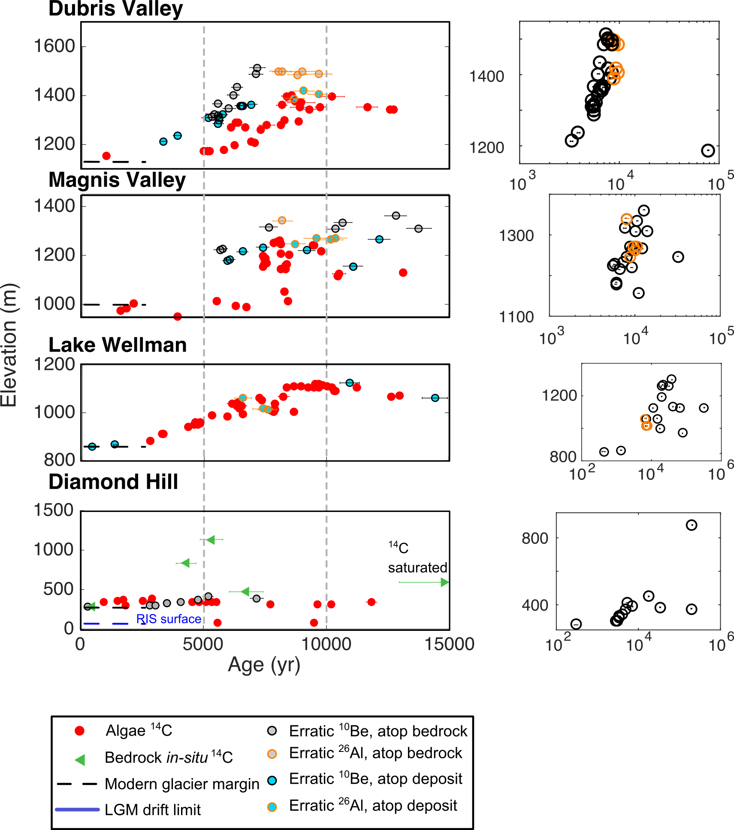

Figure 5: Output and boundary conditions of a 3D ice sheet model (Pollard and DeConto…) run at 5km for the domain shown, nested within a 20 km resolution whole ice sheet model. The model predicts 400 km of grounding-line retreat to the mouth of Darwin Glacier in ~400 years.

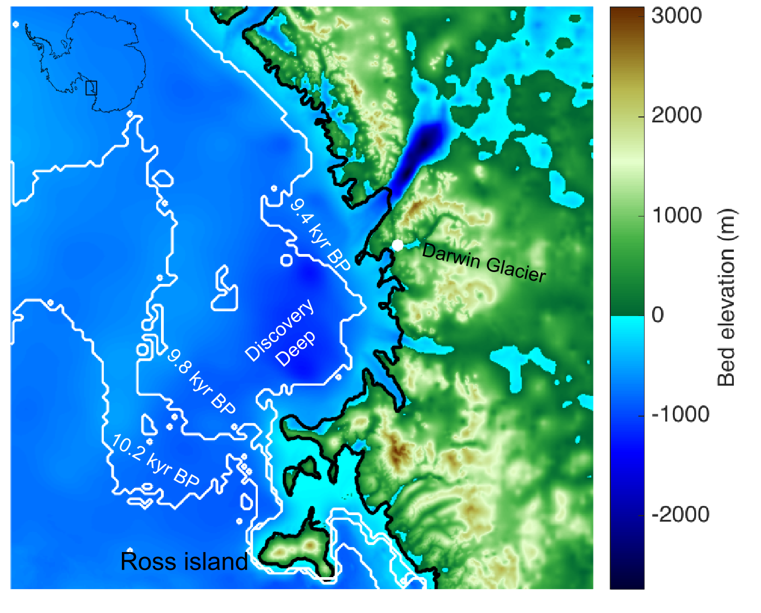

[ I would label Byrd, Mulock, maybe Hatherton or as D-H?]

Figure 6: Surface profiles from our 1.5-D flowband model forced by elevation history at the mouth of Darwing Glacier from the 3-D ice-sheet model, using the optimized parameters of Pollard et al. (2016). Middle panels show glacier profiles for Darwin and Hatherton glaciers at 1 kyr intervals (blue curves), compared to modern surface topography (dashed black curve). Locations of Lake Wellman (LW), Magnis Valley (MV), and Danum Platform (DAN) are marked. The fit of our seven runs to geochronologic data from King et al. (in press) and the present study are shown in the small panels in the bottom row. The cyan curve represents the model shown in the middle panels. Ages are color coded to match the locations in the middle panels. The deglaciation history predicted by the ice sheet model matches neither our surface exposure ages from Diamond Hill, nor the data from Hatherton Glacier.

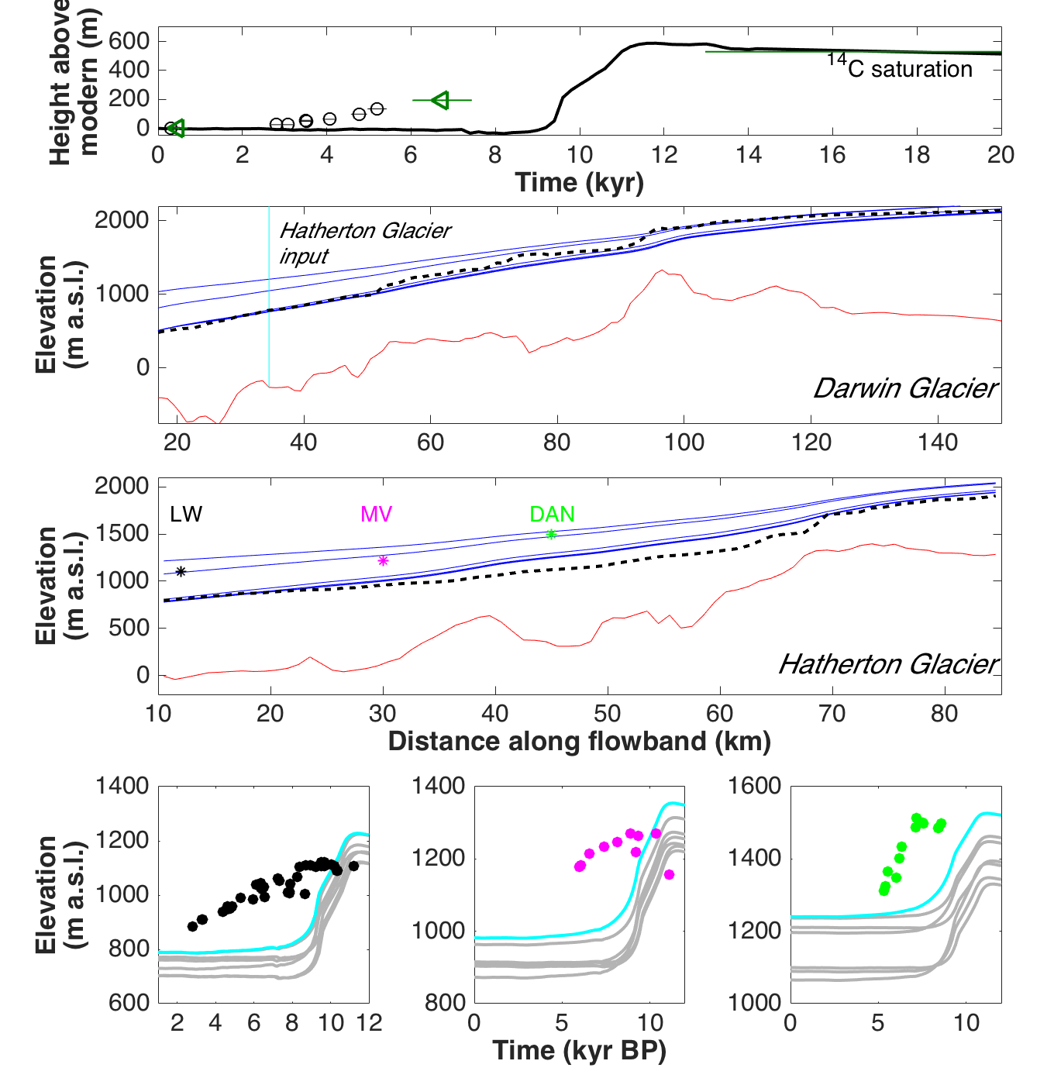

[ I think caption isn’t totally clear but may become more so after section updated with more about what ensemble members show spread in, and also more about what is calculated (evolution of glacier surface through time, and in text give timesteps, spatial steps, etc about model runs)]

Figure 7. Continuous elevation history near the mouth of Darwin Glacier from a linear interpolation between our surface exposure ages from Diamond Hill (black curve, top panel). Middle panels show glacier profiles for Darwin and Hatherton glaciers at 1 kyr intervals (blue curves), compared to modern surface topography (dashed black curve). Locations of Lake Wellman (LW), Magnis Valley (MV), and Danum Platform (DAN) are marked. The match of our small ensemble of runs to geochronologic data from King et al. (in press) and the present study are shown in the small panels in the bottom row. The cyan curve represents the model shown in the middle panels. Ages are color coded to match the locations in the middle panels. Steady thinning through the Holocene at Diamond Hill produces a much better match to the data from Hatherton Glacier than the rapid thinning case explored in Figure 6.

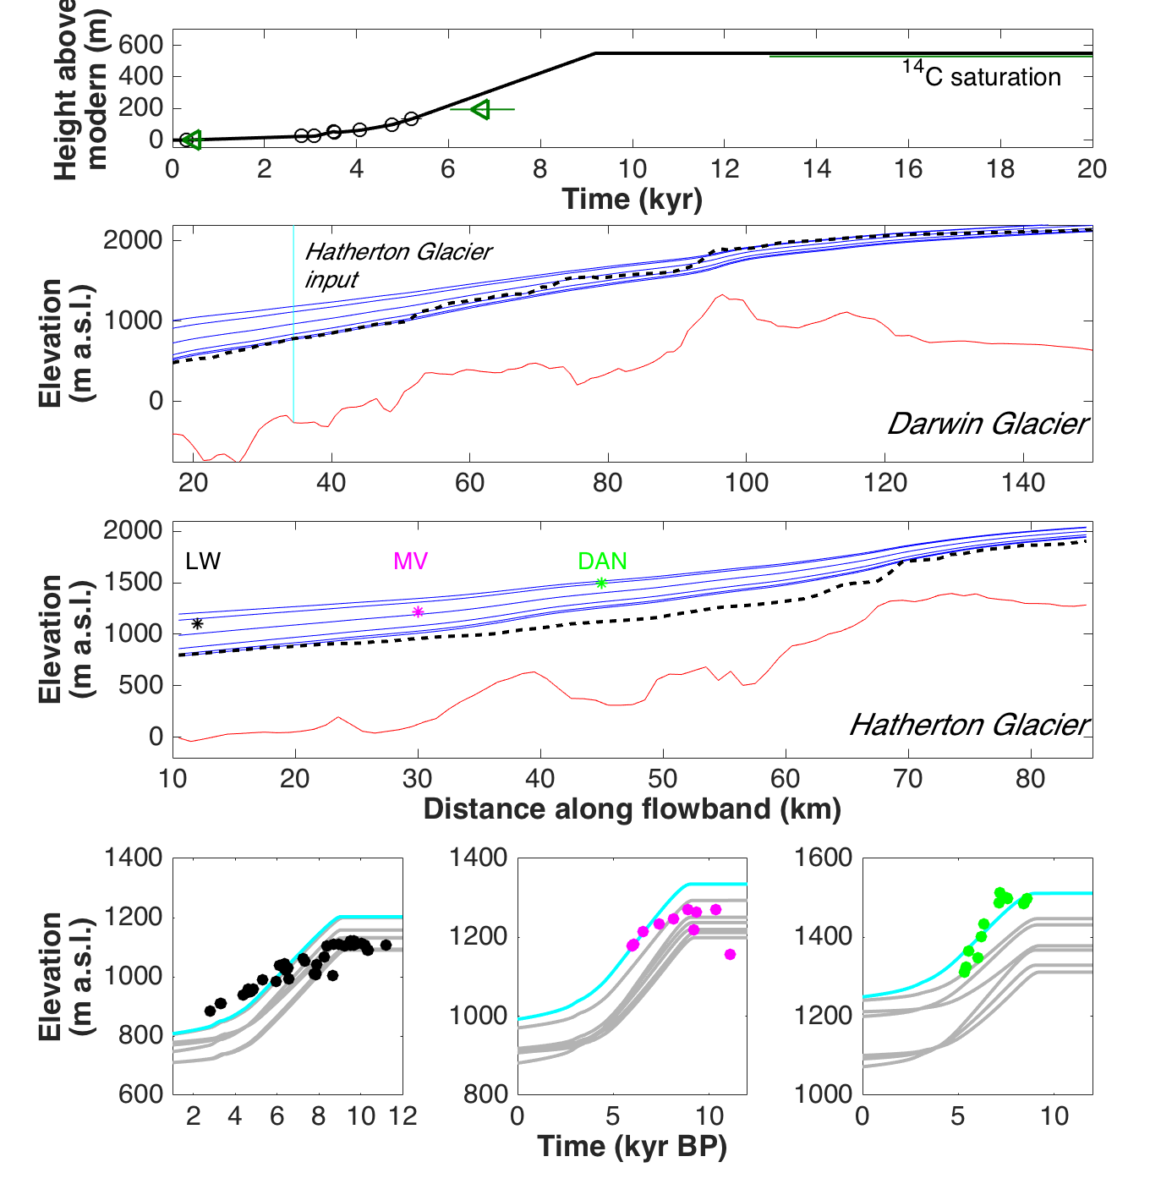

References still missing a few

1. Alley, R. B. and Whillans, I. M. (1984) ‘Response of the East Antarctica ice sheet to sea-level rise’, *Journal of Geophysical Research: Oceans*, 89(C4), pp. 6487–6493. doi: 10.1029/JC089iC04p06487.
2. Anderson, B. M., Hindmarsh, R. C. . and Lawson, W. J. (2004) ‘A modelling study of the response of Hatherton Glacier to Ross Ice Sheet grounding line retreat’, *Global and Planetary Change*, 42(1–4), pp. 143–153. doi: 10.1016/j.gloplacha.2003.11.006.
3. Anderson, J. B. *et al.* (2014) ‘Ross Sea paleo-ice sheet drainage and deglacial history during and since the LGM’, *Quaternary Science Reviews*. (Reconstruction of Antarctic Ice Sheet Deglaciation (RAISED)), 100, pp. 31–54. doi: 10.1016/j.quascirev.2013.08.020.
4. Anderson, J. T. H. *et al.* (2017) ‘Reconciling marine and terrestrial evidence for post LGM ice sheet retreat in southern McMurdo Sound, Antarctica’, *Quaternary Science Reviews*, 157, pp. 1–13. doi: 10.1016/j.quascirev.2016.12.007.
5. Baroni, C. and Hall, B. L. (2004) ‘A new Holocene relative sea-level curve for Terra Nova Bay, Victoria Land, Antarctica’, *Journal of Quaternary Science*, 19(4), pp. 377–396. doi: 10.1002/jqs.825.
6. Bintanja, R. (1999) ‘On the glaciological, meteorological, and climatological significance of Antarctic blue ice areas’, *Reviews of Geophysics*, 37(3), pp. 337–359. doi: 10.1029/1999RG900007.
7. Bockheim, J. G. *et al.* (1989) ‘Late Quaternary ice-surface fluctuations of Hatherton Glacier, Transantarctic Mountains’, *Quaternary Research*, 31(2), pp. 229–254.
8. Brown, I. C. and Scambos, T. A. (2004) ‘Satellite monitoring of blue-ice extent near Byrd Glacier, Antarctica’, *Annals of Glaciology*, 39(1), pp. 223–230. doi: 10.3189/172756404781813871.
9. Conway, H. (1999) ‘Past and Future Grounding-Line Retreat of the West Antarctic Ice Sheet’, *Science*, 286(5438), pp. 280–283. doi: 10.1126/science.286.5438.280.
10. Denton, G. H. *et al.* (1989) ‘Late Quaternary ice-surface fluctuations of Beardmore Glacier, Transantarctic Mountains’, *Quaternary Research*, 31(2), pp. 183–209. doi: 10.1016/0033-5894(89)90005-7.
11. Domack, E. W. *et al.* (1999) ‘Late Pleistocene–Holocene retreat of the West Antarctic Ice-Sheet system in the Ross Sea: Part 2—sedimentologic and stratigraphic signature’, *Geological Society of America Bulletin*, 111(10), pp. 1517–1536.
12. Dowdeswell, J. A. *et al.* (2008) ‘Submarine glacial landforms and rates of ice-stream collapse’, *Geology*, 36(10), pp. 819–822. doi: 10.1130/G24808A.1.
13. Gillespie, M. K. *et al.* (2017) ‘Geometry and ice dynamics of the Darwin–Hatherton glacial system, Transantarctic Mountains’, *Journal of Glaciology*, pp. 1–14. doi: 10.1017/jog.2017.60.
14. Gudmundsson, G. H. (2013) ‘Ice-shelf buttressing and the stability of marine ice sheets’, *The Cryosphere*, 7(2), pp. 647–655. doi: 10.5194/tc-7-647-2013.
15. Hall, B. L. *et al.* (2015) ‘Accumulation and marine forcing of ice dynamics in the western Ross Sea during the last deglaciation’, *Nature Geoscience*, 8(8), pp. 625–628. doi: 10.1038/ngeo2478.
16. Hendy, C. H. (2000) ‘Late Quaternary Lakes in the McMurdo Sound Region of Antarctica’, *Geografiska Annaler: Series A, Physical Geography*, 82(2–3), pp. 411–432. doi: 10.1111/j.0435-3676.2000.00131.x.
17. Hughes, T. *et al.* (2017) ‘Instability of the Antarctic Ross Sea Embayment as climate warms’, *Reviews of Geophysics*, 55(2), p. 2016RG000545. doi: 10.1002/2016RG000545.
18. Jackson, M. S., Hall, B. L. and Denton, G. H. (2018) ‘Asynchronous behavior of the Antarctic Ice Sheet and local glaciers during and since Termination 1, Salmon Valley, Antarctica’, *Earth and Planetary Science Letters*, 482, pp. 396–406. doi: 10.1016/j.epsl.2017.11.038.
19. Jones, R. S. *et al.* (2015) ‘Rapid Holocene thinning of an East Antarctic outlet glacier driven by marine ice sheet instability’, *Nature Communications*, 6, p. 8910. doi: 10.1038/ncomms9910.
20. Joy, K. *et al.* (2014) ‘A 2 million year glacial chronology of the Hatherton Glacier, Antarctica and implications for the size of the East Antarctic Ice Sheet at the Last Glacial Maximum’, *Quaternary Science Reviews*, 83, pp. 46–57. doi: 10.1016/j.quascirev.2013.10.028.
21. Joy, K. R. (2013) ‘A Quaternary history of ice sheet dynamics in the Transantarctic Mountains.’ Available at: http://ir.canterbury.ac.nz/handle/10092/8726 (Accessed: 15 January 2016).
22. Kavanaugh, J. L. *et al.* (2009) ‘Dynamics and mass balance of Taylor Glacier, Antarctica: 1. Geometry and surface velocities’, *Journal of Geophysical Research*, 114(F4). doi: 10.1029/2009JF001309.
23. McKay, R. *et al.* (2016) ‘Antarctic marine ice-sheet retreat in the Ross Sea during the early Holocene’, *Geology*, 44(1), pp. 7–10. doi: 10.1130/G37315.1.
24. Pollard, D. *et al.* (2016) ‘Large ensemble modeling of the last deglacial retreat of the West Antarctic Ice Sheet: comparison of simple and advanced statistical techniques’, *Geoscientific Model Development*, 9(5), pp. 1697–1723. doi: 10.5194/gmd-9-1697-2016.
25. Pollard, D. and DeConto, R. M. (2009) ‘A coupled ice-sheet/ice-shelf/sediment model applied to a marine-margin flowline: forced and unforced variations’, *Glacial Sedimentary Processes and Products, edited by: Hambrey, MJ, Christoffersen, P., Glasser, NF, and Hubbard, B., International Association of Sedimentologists Spec. Pub*, 39, pp. 37–52.
26. Raymond, C. F. (1983) ‘Deformation in the Vicinity of Ice Divides’, *Journal of Glaciology*, 29(103), pp. 357–373. doi: 10.3189/S0022143000030288.
27. Spector, P. *et al.* (no date) ‘Rapid early-Holocene deglaciation in the Ross Sea, Antarctica’, *Geophysical Research Letters*, p. 2017GL074216. doi: 10.1002/2017GL074216.
28. Stearns, L. A. (2011) ‘Dynamics and mass balance of four large East Antarctic outlet glaciers’, *Annals of Glaciology*, 52(59), pp. 116–126.
29. Stone, J. O. (2003) ‘Holocene Deglaciation of Marie Byrd Land, West Antarctica’, *Science*, 299(5603), pp. 99–102. doi: 10.1126/science.1077998.
30. Storey, B. C. *et al.* (2010) ‘Cosmogenic nuclide exposure age constraints on the glacial history of the Lake Wellman area, Darwin Mountains, Antarctica’, *Antarctic Science*, 22(06), pp. 603–618. doi: 10.1017/S0954102010000799.
31. Stuart, R. K. *et al.* (2015) ‘Cyanobacterial reuse of extracellular organic carbon in microbial mats’, *The ISME Journal*, 10(5), p. 1240. doi: 10.1038/ismej.2015.180.
32. Swithinbank, C., Brunk, K. and Sievers, J. (1988) ‘A glaciological map of Filchner-Ronne ice shelf, Antarctica’, *Ann. Glaciol*, 11, pp. 150–155.
33. Thomas, R. H. *et al.* (1984) *Glaciological studies on the Ross ice shelf, Antarctica, 1973–1978*. Wiley Online Library. Available at: http://onlinelibrary.wiley.com/doi/10.1029/AR042p0021/summary (Accessed: 28 October 2016).
34. Todd, C. *et al.* (2010) ‘Late Quaternary evolution of Reedy Glacier, Antarctica’, *Quaternary Science Reviews*, 29(11–12), pp. 1328–1341. doi: 10.1016/j.quascirev.2010.02.001.
35. Vincent, W. F. and Howard-Williams, C. (1994) ‘Nitrate-rich inland waters of the Ross Ice Shelf region, Antarctica’, *Antarctic Science*, 6(03). doi: 10.1017/S0954102094000519.
36. Waddington, E. D. *et al.* (2005) ‘Decoding the dipstick: Thickness of Siple Dome, West Antarctica, at the last glacial maximum’, *Geology*, 33(4), pp. 281–284.
37. Webster, J. *et al.* (1996) ‘Evidence for regional climate change in the recent evolution of a high latitude pro-glacial lake’, *Antarctic Science*, 8(1), pp. 49–59. doi: 10.1017/S0954102096000090.
38. Webster, J. G., Brown, K. L. and Vincent, W. F. (1994) ‘Geochemical processes affecting meltwater chemistry and the formation of saline ponds in the Victoria Valley and Bull Pass region, Antarctica’, *Hydrobiologia*, 281(3), pp. 171–186.
39. Webster-Brown, J. *et al.* (2010) ‘The biogeochemistry of meltwater habitats in the Darwin Glacier region (80°S), Victoria Land, Antarctica’, *Antarctic Science*, 22(06), pp. 646–661. doi: 10.1017/S0954102010000787.